|  |  |  |  |
| --- | --- | --- | --- |
| Linzer biol. Beitr. | 00/0 | 000-000 | 00.00.0000 |

A new species and a new record of *Aphaenostemmus* from southern Turkey   
(Coleoptera: Staphylinidae: Omaliinae)

Volker Author

Abstract: *Aphaenostemmus distortus* nov.sp. (Turkey: Antalya) is described, illustrated, and distinguished from other *Aphaenostemmus* species recorded from the West Palaearctic region. *Aphaenostemmus rhodicus* Assing, 2006, which was previously known only from the Greek island Rhodes, is reported from Turkey for the first time. The male sexual characters of *A. rhodicus* and *A. bordei* Peyerimhoff, 1914 are illustrated for the first time.

Key words: Coleoptera, Staphylinidae, Omaliinae, *Aphaenostemmus*, Palaearc­tic region, Turkey, taxonomy, new species, new record.

# Introduction

The genus *Aphaenostemmus* Peyerimhoff, 1914, one of the two genera of Aphaenostemmini, was attributed to the Omaliinae by Newton & Thayer (1995) and previously comprised six species distributed from the Mediterranean (two species) across the Middle East (one species) to the Himalaya (three species) (Assing 2006; Herman 2001; Smetana 2004). As far as can be inferred from the few known records, *Aphaenostemmus* species appear to be associated with river beds. Illustrations of the male genitalia have not been published.

Recently, Jürgen Vogel (Görlitz) sent me two species of Staphylinidae from southern Turkey for identification. One of them was readily identified as *Aphaenostemmus rhodicus*, Assing 2006 (new country record). The other, represented by a male and three females in rather poor condition, puzzled me at first. It was only after the dissection of the aedeagus that I realized that these specimens belonged to an undescribed species of the same genus.

# Material and measurements

The material treated in this study is deposited in the following collections:

cAss author´s private collection

cVog private collection Jürgen Vogel, Görlitz

The morphological studies were conducted using a Stemi SV 11 microscope (Zeiss Ger­many) and a Jenalab compound microscope (Carl Zeiss Jena). A digital camera (Nikon Coolpix 995) was used for the photographs.

Body length was measured from the anterior margin of the labrum to the abdominal apex, the length of the forebody from the anterior margin of the mandibles (in resting position) to the posterior margin of the elytra, head length along the middle from the anterior margin of the clypeus (without ante-clypeus) to the posterior mar­gin of the head, head width including eyes, elytral length at the suture from the apex of the scutel­lum to the posterior margin of the elytra, and the length of the aedeagus from the apex of the ventral process to the base of the aedeagal capsule. The "parameral" side (i.e., the side where the sperm duct enters) is referred to as the ventral, the opposite side as the dorsal aspect.

# Description and additional record

## *Aphaenostemmus distortus* nov.sp. (Figs 1-7)

Type material: Holotype ?: "TURKEY - Antalya, Göynuk near Kemer, 36°39'N, 30°31'E, 7.-14.V.2009, Sieber / Holotypus ? *Aphaenostemmus distortus* sp.n. det. V. Assing 2013" (cAss). Paratypes: 3//: same data as holotype (cAss, cVog).

Etymology: The name (Latin, adjective: distorted, twisted) alludes to the asym­metric aedeagus.

Description: Small species; body length 2.2-2.3 mm; length of forebody 1.1-1.2 mm. Habitus as in Fig. 1. Coloration: head blackish-brown; pronotum dark-brown; elytra yellowish; abdomen dark-brown to blackish-brown, with the apex (posterior margin of segment VII; segments VIII-X) reddish; legs and antennae yellowish.

Head (Figs 2-3) approximately as long as broad, broadest across eyes; punctation rather coarse and dense; interstices with distinct microreticulation. Eyes large, approximately twice as long as postocular region in dorsal view. Antenna (Fig. 4) 0.6-0.7 mm long, distinctly incrassate apicad; antennomere IV approximately as long as broad; V weakly transverse; VI-X increasingly transverse and of gradually increasing width; X approxi­mately 1.5 times as broad as long.

Pronotum (Figs 2-3) weakly transverse, approximately 1.05 times as broad as long and about 1.1 times as broad as head, maximal width in anterior half; punctation finer than that of head; interstices with distinct microreticulation.

Elytra (Fig. 2) long, 1.3-1.4 times as long as pronotum; punctation fine and dense. Hind wings fully developed.

Abdomen narrower than elytra; punctation fine and dense on tergites III-VII, sparser and finer on tergite VIII; interstices with shallow microsculpture and somewhat glossy.

?: aedeagus (Figs 5-7) approximately 0.45 mm long and distinctly asymmetric; internal sac with dark coiled tube.

Comparative notes: This species is readily distinguished from all its West Palaearctic congeners by numerous characters, particularly its much smaller size (other species: body length > 3.2 mm; length of forebody > 1.5 mm), the much shorter and more

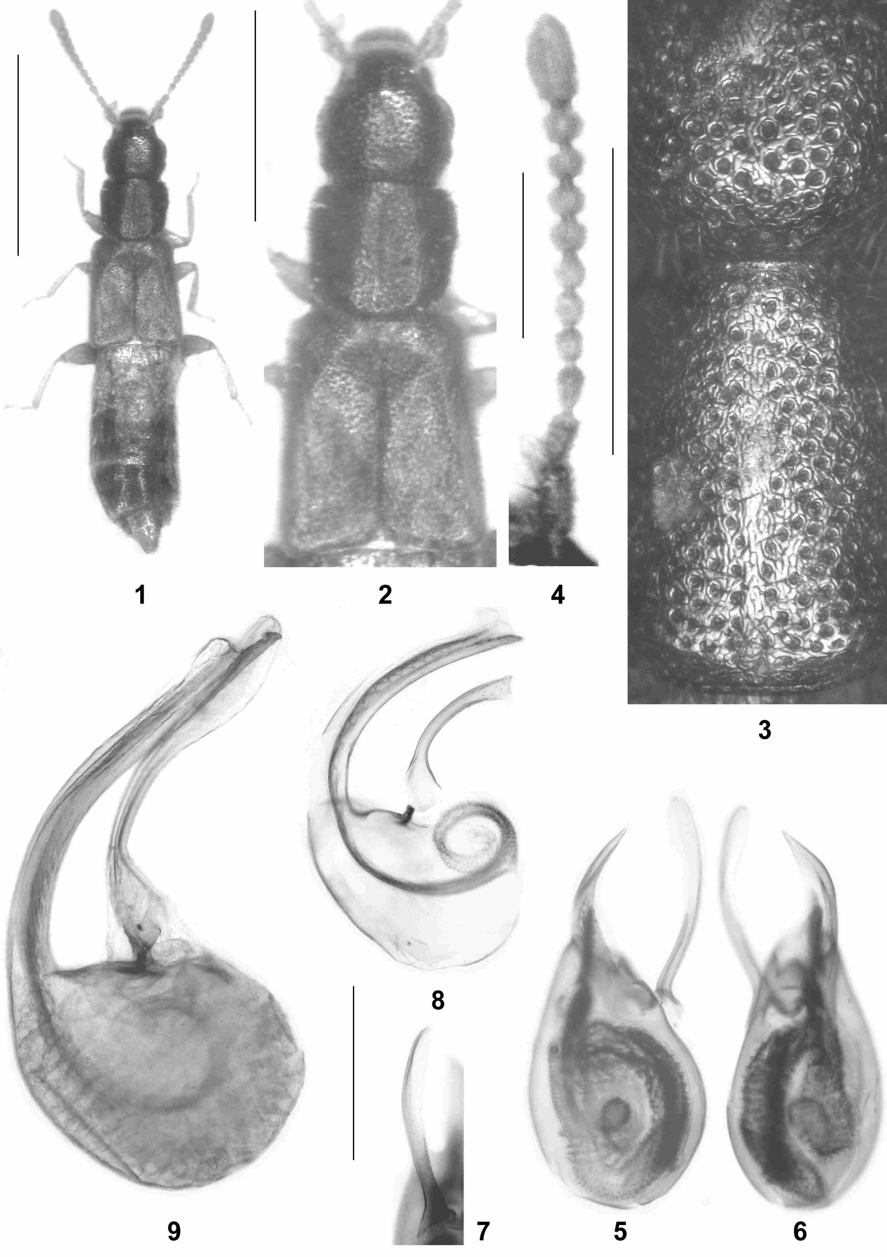

**Figs 1-9**: *Aphaenostemmus distortus* nov.sp. (**1-7**), *A. rhodicus* Assing (Turkey) (**8**), and *A. bordei* Peyerimhoff (Tunisia) (**9**): (**1**) habitus; (**2**) forebody; (**3**) postero-median portion of head and median portion of pronotum; (**4**) antenna; (**5, 8, 9**) aedeagus in lateral view; (**6**) aedeagus in ventral view; (**7**) paramere in ventral view. Scale bars: 1: 1.0 mm; 2: 0.5 mm; 3-9: 0.2 mm.

strongly incrassate antennae (other species: at least antennnomeres V-VII oblong), the more pronounced microreticulation on the head and the pronotum, and the morphology of the aedeagus (other species: symmetric; ventral process more strongly curved in lateral view; internal tube much paler and more slender).

Distribution and natural history: The type locality is situated in the west of Antalya province, southwestern Turkey. According to the collector, the specimens were hand-netted on the wing at a road margin, not far from a riverbed, during sunset (Vogel pers. comm.).

## *Aphaenostemmus rhodicus* Assing, 2006 (Fig. 8)

Material examined: Turkey: 1?, 1/, Antalya, Göynuk near Kemer, 36°39'N, 30°31'E, 14.V.2009, leg. Sieber (cAss).

Comment: This species was previously known only from the Greek island Rhódos (Assing 2006). The above specimens represent the first record from Turkey. They were collected in the same locality and under the same circumstances as *A. distortus*. The previously unknown symmetric aedeagus is characterized as follows: length 0.39 mm; ventral process very slender, strongly curved in lateral view, and apically acute; parameres short and apically truncate; internal tube long and weakly sclerotized (Fig. 8). The aedeagus of *A. rhodicus* differs from that of the closely related and externally similar *A. bordei* Peyerimhoff, 1914 from North Africa (Algeria, Tunisia) by distinctly smaller size (*A. bordei*: length 0.65 mm), the smoothly curved ventral process (*A. bordei*: straight in apical half), the simply pointed apex of the ventral process (*A. bordei*: apex with short dorso-apical process), and by the much shorter and apically truncate parameres. The aedeagus of a male of *A. bordei* from Tunisia is illustrated in Fig. 9.

# Key to the Palaearctic and Oriental species of *Micrillus* and *Scymbalium*

For convenience, *Micrillus aethiopicus*, a close relative of *M. aegyptiacus*, is included in the key, although this species has been recorded only from the Afrotropical region.

1 Protarsomeres I-IV dilated in both sexes. Species of moderately large to large size; body length > 7.0 mm; length of forebody > 3.8 mm. Genus *Scymbalium*Erichson 2

- Protarsomeres I-IV not dilated. Small to moderately large species; body length 3.2-9.0 mm; length of forebody 1.8-4.0 mm. Genus *Micrillus* Raffray 5

2 Head and pronotum with distinct and moderately dense punctation (Fig. 3). West Palaearctic region 3

- Head and pronotum with very fine (sometimes except for some scattered macropunctures on frons), sparse or very dense punctation (Figs 6, 57, 61). East Palaearctic and Oriental regions 4

3 Abdomen with very fine punctation (Fig. 4). Iraq, Russian South European territory   
 ***S. persimile*** Cameron

- Abdomen with distinctly coarser punctation. Widespread, from France and Algeria to Turkmenistan and Iran ***S. anale*** (Nordmann)

4 On average larger species of more robust habitus (Fig. 56); body length 8.5-9.5 mm; length of forebody 4.8-5.1 mm. Head with rather dense and moderately fine punctation (Fig. 57). Male sternite VIII with deeper posterior concavity (Fig. 58). Ventral process of aedeagus apically more slender and more strongly bent dorsad in lateral view (Figs 59-60). Northeastern India; Bhutan; Myanmar ***S. badium*** (Motschulsky)

- On average smaller species of more slender habitus (Figs 5-6, 63); body length 7.5-8.5 mm; length of forebody barely 3.9-4.7 mm. Head with extremely fine and sparse punctation (Fig. 61). Male sternite VIII with shallowly concave posterior margin (Figs 62, 64). Aedeagus 0.6-0.7 mm long, ventral process apically stouter and less strongly bent dorsad in lateral view (Figs 7-8, 65-66). Nepal ***S. nepalense*** nov.sp.

5 Apical joint of maxillary palpus long and slender, at least half the length of preapical palpomere (Assing 2008: figure 39). Aedeagus of simple morphology, symmetric, usually slender with ventral process apically more or less bent dorsad; internal structures amorphous and weakly sclerotised. West Palaearctic region (including Middle Asia); absent from Egypt (Assing 2008: figure 2). *Micrillus testaceus* group 6

- Apical joint of maxillary palpus of conical shape and usually shorter than half the length of preapical palpomere, only in one species from the Oriental region longer. Aedeagus of complex morphology, usually asymmetric and/or with more or less distinctly sclerotised internal structures. Afrotropical, East Palaearctic, and Oriental regions, in the West Palaearctic confined to Egypt and Yemen. *Micrillus aegyptiacus* and *M. suturalis* groups 13

6 Eyes fully developed or of reduced size, but always composed of ommatidia. Posterior margin of abdominal tergite VII at least with narrow rudiment of a palisade fringe. 7

- Eyes extremely reduced, without ommatidia. Abdominal tergite VII without palisade fringe. Distribution confined to North Africa 11

7 Posterior margin of head distinctly concave in the middle (Assing 2008: figure 61). Eyes, elytra, and hind wings not reduced (Assing 2008: figures 59-60, 62). Posterior margin of male sternite VIII with deeply and broadly triangular excision (Assing 2008: figure 64). Aedeagus as in Assing 2008: figures 66-74. Known distribution confined to Iraq, Israel, and Iran ***M. irakensis*** (Cameron)

- Posterior margin of head not distinctly concave, usually truncate. Aedeagus of different morphology. 8

8 Species of pale (yellowish, reddish or pale brown) coloration. Eyes, elytra, and hind wings not reduced (Assing 2008: figures 48-49). Posterior margin of male sternite VIII with shallow emargination (Assing 2008: figure 50). Aedeagus of distinctive shape, rather broad in ventral view, ventral process apically not bent dorsad, and with two clusters of moderately sclerotised internal structures (Assing 2008: figures 51-55). Caucasus region and Middle Asia ***M. pallidus*** (Reitter)

- Mature specimens usually (but not always!) of darker coloration, reddish to dark brown. Eyes, elytra, and hind wings often of reduced size or length, respectively. Aedeagus more slender, with one cluster of internal structures and with ventral process apically bent dorsad 9

9 Wing-dimorphic, on average smaller species; eyes on average larger. Elytra and abdomen with finer punctation (Assing 2008: figure 11). Posterior margin of male sternite VIII with deeper triangular emargination (Assing 2008: figure 13). Widespread species with slender aedeagus with more weakly sclerotised ventral process (Assing 2008: figures 16-26), or distribution confined to Algeria 10

# Acknowledgements

I am indebted to Jürgen Vogel, Görlitz, for the generous gift of reference material of *A. distortus* and *A. rhodicus* from Turkey. Benedikt Feldmann, Münster, proof-read the manuscript.

# Zusammenfassung

*Aphaenostemmus distortus* nov.sp. (Türkei: Antalya) wird beschrieben, abgebildet und von anderen westpaläarktischen *Aphaenostemmus*-Arten unterschieden. *Aphaenostemmus rhodicus* Assing, 2006, bislang nur von der griechischen Insel Rhodos bekannt, wird erstmals aus der Türkei nach­gewiesen. Die männlichen Sexualmerkmale von *A. rhodicus* und *A. bordei* Peyerimhoff, 1914 werden erstmals abgebildet.

# References

Assing V. (2006): New species and records of Staphylinidae from Greece, with two new synonymies (Insecta: Coleoptera). — Linzer biologische Beiträge **38** (1): 333-379.

Herman L.H. (2001): Catalog of the Staphylinidae (Insecta: Coleoptera). 1758 to the end of the second millennium. Volumes I-VII. — Bulletin of the American Museum of Natural History **265** (2): 1-4218.

Newton A.F. & M.K. Thayer (1995): Protopselaphinae new subfamily for *Protopselaphus* new genus from Malaysia, with a phylogenetic analysis and review of the Omaliine Group of Staphylinidae including Pselaphidae (Coleoptera) — In: Pakaluk J. & S. Ślipiński (eds), Biology, Phylogeny, and Classification of Coleoptera. Papers celebrating the 80th birthday of Roy A. Crowson. — Warszawa: Muzeum i Instytut Zoologii PAN: 219-320.

Smetana A. (2004): Staphylinidae, subfamily Omaliinae, pp. 237-268. — In: Löbl I. & A. Smetana (eds), Catalogue of Palaearctic Coleoptera. II. Hydrophiloidea-Histeroidea-Staphylinoidea. — Stenstrup, Apollo Books: 942 pp.

Newton A.F., Thayer M.K., Ashe J.S. & D.S. Chandler (2001): 22. Staphylinidae Latreille, 1802, pp. 272-418. In: Arnett R.H. & M.C. Thomas, American Beetles, Volume 1: Archostemmata, Myxophaga, Adephaga, Polyphaga: Staphyliniformia. — Boca Raton, London, New York, Washington: CRC Press, I-XVI, 1-443

Author´s address: Volker Author

Gabelsbergerstr. 2

D-30163 Hannover, Germany

E-mail: please add it!!!